Converting Windows OS BIOS Mode from Legacy BIOS to UEFI on a VM

# Creating WIN PE

* **Creating the bootable WIN PE ISO only needs to be done once. It will be reused for each computer that you want to convert.**
* Download and install Windows Assessment and Deployment Kit with WIN PE Tools
  + You only need to install Deployment tools

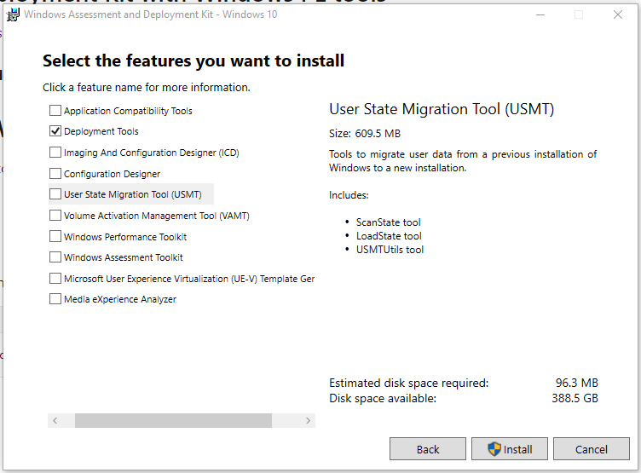

* Then install WINPE Addon
* Create WIN PE
  + <https://docs.microsoft.com/en-us/windows-hardware/manufacture/desktop/winpe-create-usb-bootable-drive>
  + Start the deployment and imaging tools environment as an administrator

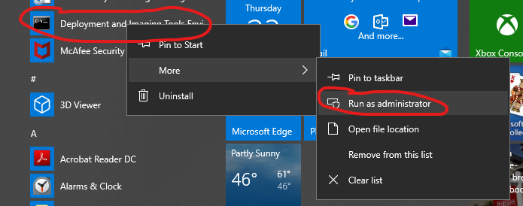

* + Create WINPE working files
    - CopyPE amd64 <Path>
      * Where path is a directory you want to create the file
  + To complete the following you can do it manually or modify the included Build WINPE.PS1 script
    - <https://docs.microsoft.com/en-us/windows-hardware/manufacture/desktop/winpe-mount-and-customize>
    - Mount the Image
    - Add Powershell to the WINPE Disk
      * <https://docs.microsoft.com/en-us/windows-hardware/manufacture/desktop/winpe-adding-powershell-support-to-windows-pe>
    - Copy the powershell scripts to the scripts directory (you will have to create the directory first)
      * ConvertTo-UEFI.ps1
      * Write-Log.ps1
    - Add MBR2GPT to the WINPE Files
      * For some reason the MBR2GPT that comes with the WINPE 1909 didn’t work. So I copied the one from my WIN 10 1803 machine to a new directory in the Mount folder.
      * Copy from the c:\windows\system32 directory to the Scripts directory
    - Edit the windows\system32\startnet.cmd and add the following line to the end
      * Powershell -executionpolicy bypass -file c:\scripts\convertto-UEFI.ps1
    - Dismount and commit the image
    - Create Bootable ISO
      * MkaeWINPEMedia /ISO <Path> <path and name of new ISO>
      * The script uses OSCDIMG.exe to do the same

Upload to vCenter Datastore

* Again you can do this manually or the script has this included.

Automated Converting VM BIOS

* The WINPE ISO that we just created will run a script to convert the BIOS to UEFI automatically.
* The UEFIVCenter.ps1 script will automate the process of
  + Creating Snapshot
  + Mounting ISO on the VM CDROM
  + Changing the VM BOOT Order
  + Booting into WINPE
    - Here the WINPE Script takes over and converts to UEFI OS
    - Shuts down the VM
  + Once the VM is shut down this script continues
  + Changing the VM BIOS to EFI
  + Setting the boot order back to original
  + Starting the VM in UEFI mode.

# Manual Example Converting VM BIOS

* Create a snapshot of the VM. If the VM does not boot after the conversion, you can restore the snapshot to recover the VM to before the conversion.
* Mount ISO to VM
* Reboot to WINPE ISO
* Determine the System disk this will be used in the next step
* Validate against the system disk
  + MBR2GPT.EXE /validate /disk:0
  + if no errors continue
* Convert the disk
  + MBR2GPT /convert /disk:0

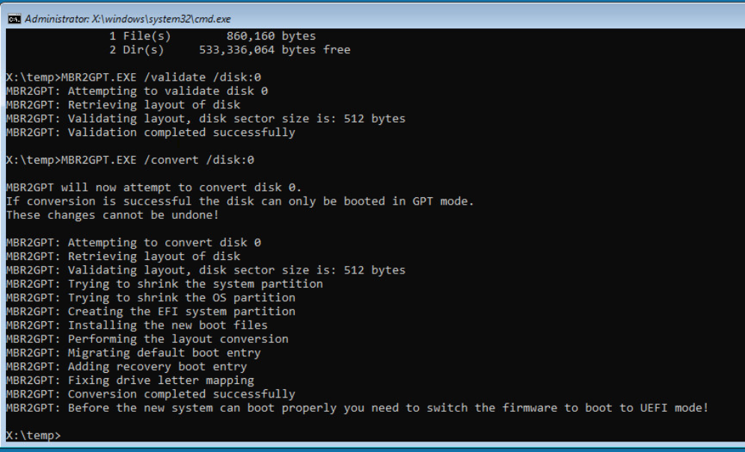

* Power off VM
* Change the Hardware Firmware in VMware
  + Edit Settings
  + VMOptions
  + Boot Option
  + Firmware

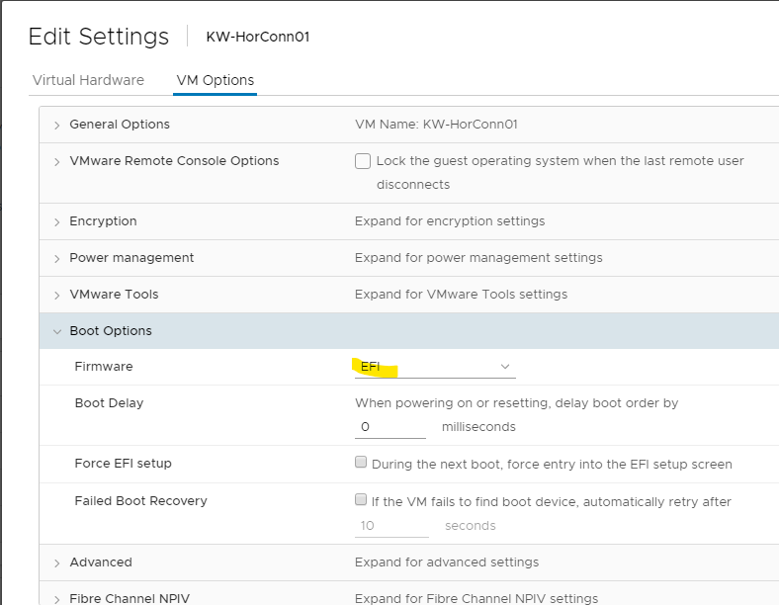

* Boot Server

# Verify Windows is booting with UEFI

## GUI

* Log into windows
* Run MSINFO32.exe
* Check the BIOS Mode

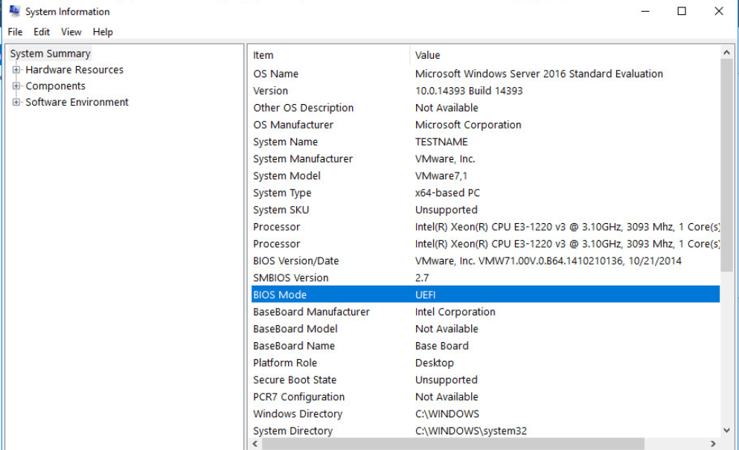

## PowerShell

* This can also be used with a list of computers to see which machines have been converted and which need to be completed

Invoke-command -ComputerName $C -Scriptblock { Get-ComputerInfo | Select-Object BIOSFirmwareType }

